Coverings of kidney

Features
- A unique arrangement of fascia and fat surrounds kidneys
- Three layers
  - Fibrous capsule
  - Perinephric fat
  - Renal fascia

Fibrous capsule (true capsule)
Condensation of fibrous tissue of kidney

Perinephric fat (perirenal fat)
- Accumulation of extraperitoneal fat
- Immediately outside the renal capsule
- Completely surrounds the kidney

Renal fascia (fascia of Gerota)
- Membranous condensation of the extraperitoneal fascia
- Suprarenal glands are also enclosed in this fascial compartment
- Anterior layer – fascia of Toldt
- Posterior layer – fascia of Zuckerkandl

[TIP] The renal fascia must be incised in any surgical approach to kidney

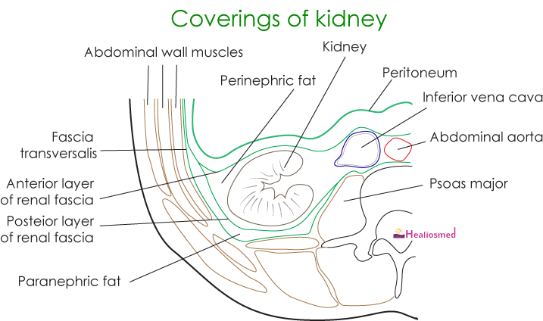

Pararenal fat fills
Pararenal fat cells fills the paravertebral gutter and forms cushion to kidneys posteriorly.

